ACCOMPLISHMENT REPORT
IT 205 & 205L – Object-Oriented Programming
Month: October – Year: 2025
School Year: 2025 – 2026 1st Semester

DATE | ACCOMPLISHMENT | REMARKS  (Progress and deviations from the plan) *
October 1 – 11, 2025 | Lecture Accomplishments:  - Conducted systematic review of Module 1: Introduction to OOP and the ‘this’ keyword, reinforcing the core concepts of classes, objects, encapsulation, abstraction, and inheritance.  - Revisited the role of the `this` keyword in different JavaScript contexts (methods, constructors, and global scope) to address common misconceptions observed in previous quizzes and recitations.  - Reviewed key ideas from Module 2: Prototyped Chains and Advanced OOP Concepts, emphasizing prototype chains, object delegation, and the comparison between classical inheritance and prototype-based inheritance.  - Facilitated guided discussions connecting Modules 1 and 2 to the course outcomes and program outcomes (problem analysis, design of solutions, and modern tool usage), ensuring students see how these concepts contribute to real-world software development.  Laboratory Accomplishments:  - Administered hands-on review coding exercises where students refactored previous activities using clearer comments and improved code organization, reinforcing CO3 (coding standards and documentation).  - Conducted practice tasks on prototype chains, including creating objects that inherit from other objects and observing property/method lookup along the chain.  - Implemented short formative quizzes and problem-solving drills (both written and practical) to diagnose readiness for the midterm exam and provide targeted feedback. | Accomplished (Used as structured review and reinforcement for Modules 1 and 2 in preparation for the Midterm Examination, following the course syllabus and learning outcomes.)
October 13 – 17, 2025 | Lecture Accomplishments: [EXAMINATION WEEK]  - Administered the Midterm Written Examination covering Modules 1 and 2 (OOP concepts, this keyword behavior, prototype chains, and comparison between procedural and object-oriented approaches).  - Ensured proper implementation of exam protocols (seating arrangement, instructions, academic integrity reminders, and time management).  - Performed initial checking and scoring of midterm written exam papers and recorded results for grading and documentation purposes.  Laboratory Accomplishments: [EXAMINATION WEEK]  - Administered the Midterm Practical / Laboratory Examination, requiring students to design and implement JavaScript programs that demonstrate the use of objects, this, and prototype-based features.  - Observed and documented students’ coding practices, focusing on correctness, use of OOP principles, and basic documentation.  - Checked, scored, and recorded laboratory midterm outputs and performances, integrating results into the laboratory grade component.  - Prepared and organized evidence of midterm results (exam papers, score sheets, and sample code outputs) for submission and possible future audit. | Accomplished (Midterm written and practical examinations were conducted)
October 20 – 24, 2025 | Lecture Accomplishments:  - Officially opened Module 3: Constructors and Object Initialization, presenting the intended learning outcomes based on the course syllabus (mastering constructor functions, object initialization, and understanding prototype relationships).  - Explained the concept and role of constructor functions in object-oriented programming, including how they are used to create and initialize objects with specific properties.  - Discussed the relationship between constructors and prototypes, showing how methods can be placed on the prototype to promote memory efficiency and reusability.  - Introduced the idea of constructor overloading (using default parameters and different initialization strategies) and compared different constructor patterns used in JavaScript.  - Connected Module 3 content to Graduate Attributes such as problem solving, conceptual thinking, and critical thinking by discussing how good constructor design supports scalable and maintainable systems.  Laboratory Accomplishments:  - Guided students in writing custom constructor functions (e.g., for simple entities like Student, Course, or Product) and instantiating multiple objects with varying property values.  - Conducted exercises where students attached methods to the constructor’s prototype, then tested method sharing across multiple instances.  - Implemented a short laboratory quiz / practical check focusing on syntax, proper use of new, property initialization, and basic prototype usage.  - Provided immediate feedback on submitted lab work and clarified errors related to object creation, improper use of this, and missing prototype references. | Accomplished (Module 3 concepts were introduced and applied through guided laboratory activities, in line with the course outcomes for constructors and object initialization.)
October 27 – 30, 2025 | Lecture Accomplishments:  - Deepened discussion on constructor patterns, including the prototype pattern and simple module-style patterns, highlighting their advantages and trade-offs in terms of maintainability and performance.  - Presented sample code refactoring scenarios where plain object literals were converted into constructor-based structures to improve modularity and consistency.  - Analyzed small case studies where constructor functions are used in real-world applications (e.g., managing collections of domain objects such as users, orders, or items).  - Linked Module 3 to the upcoming Module 4 (Inheritance and Polymorphism) by showing how constructors serve as a foundation for constructing inheritance hierarchies.  Laboratory Accomplishments:  - Conducted a mini-laboratory project where students designed a small set of related constructors and instantiated multiple objects to simulate real-world data.  - Facilitated debugging and code review sessions, where students inspected each other’s constructor-based programs and suggested improvements, strengthening peer-learning and professional communication.  - Verified and recorded completion of laboratory activities for Module 3, ensuring outputs are aligned with CO2 (Perform OOP integrating appropriate programming solutions) and CO3 (adopt appropriate coding standards with documentation).  - Prepared documentation (screenshots of outputs, selected code samples, and activity summaries) as proof/evidence of accomplishments. | Accomplished (Module 3 coverage was continued and reinforced through a mini-project and peer-review activities; students are being prepared for deeper inheritance and polymorphism topics in the succeeding sessions.)
*Provide relevant documentation such as pictures, summary reports, etc.

Prepared by: Approved:

JUNNIE RYH M. SUMACOT SHERWIN G. CADAY, PhD.
Instructor Program Chair

PROOF/EVIDENCE OF REPORTED ACCOMPLISHMENTS
IT 205 & 205L – Object-Oriented Programming
Month: October – Year: 2025
School Year: 2025 – 2026 1st Semester

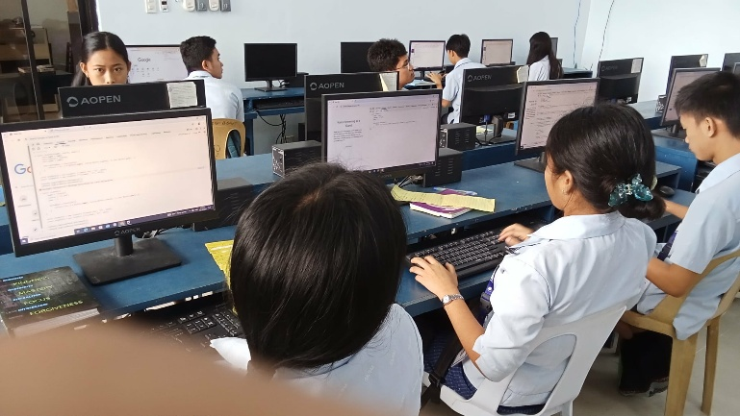
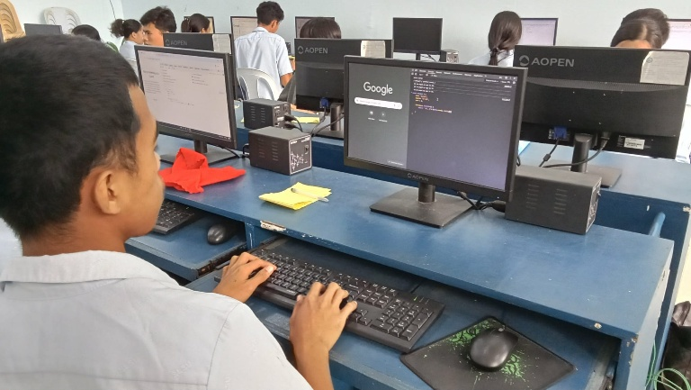



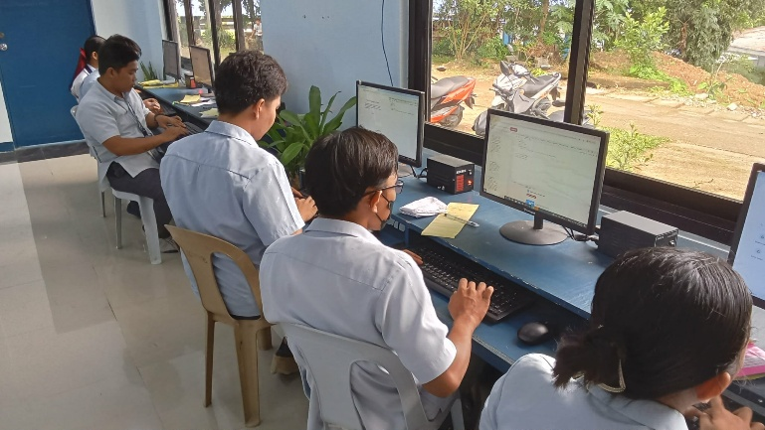

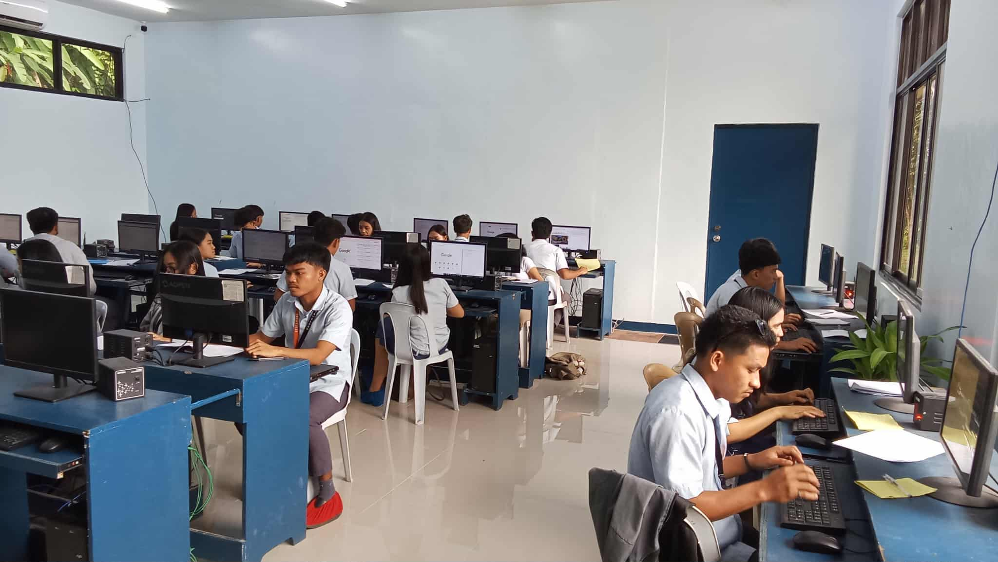
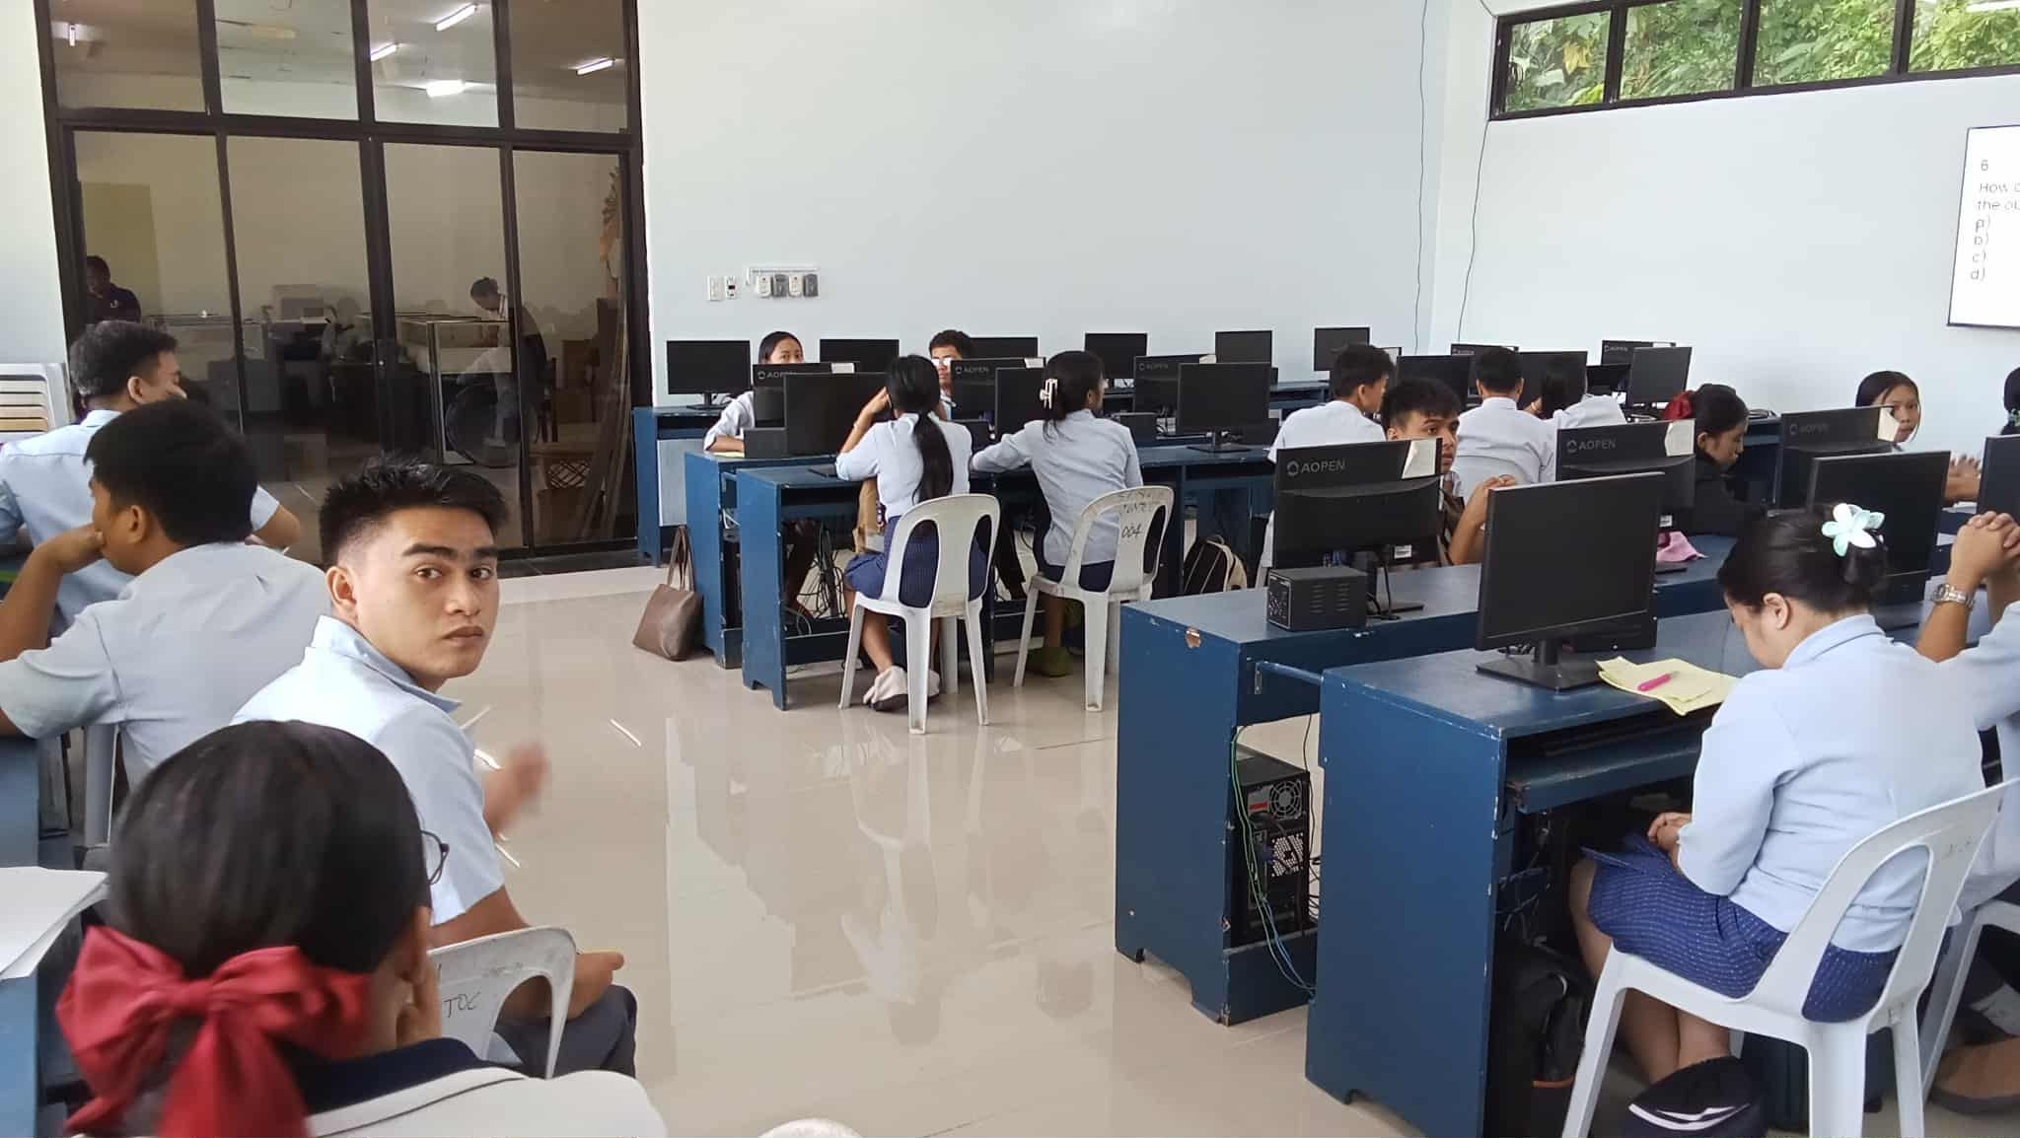

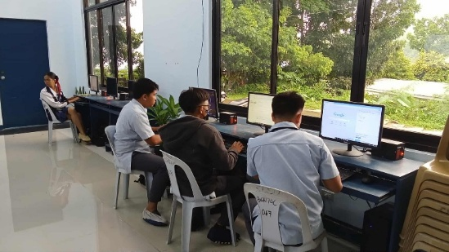

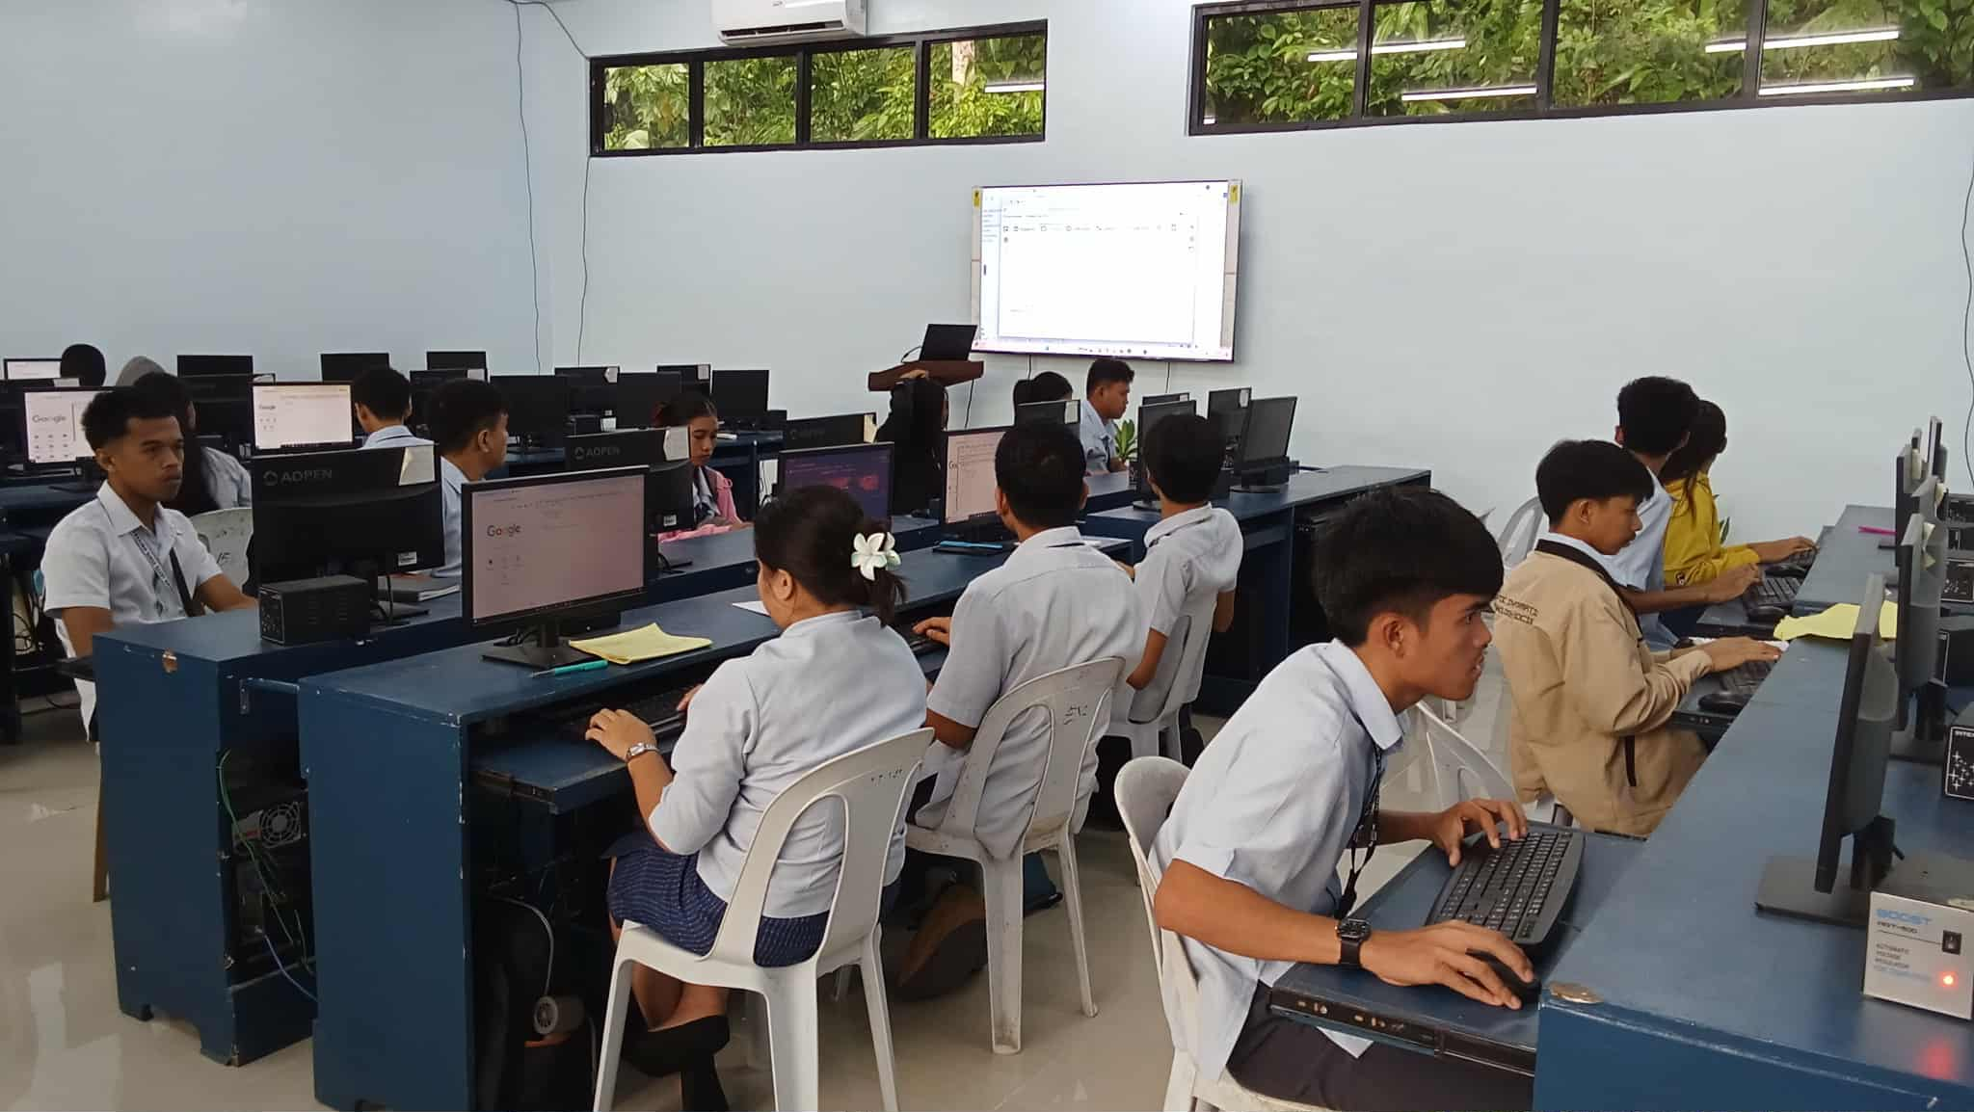


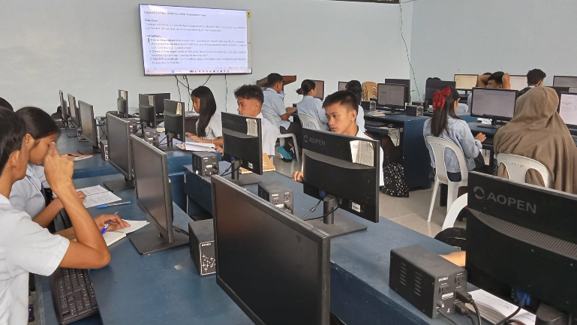
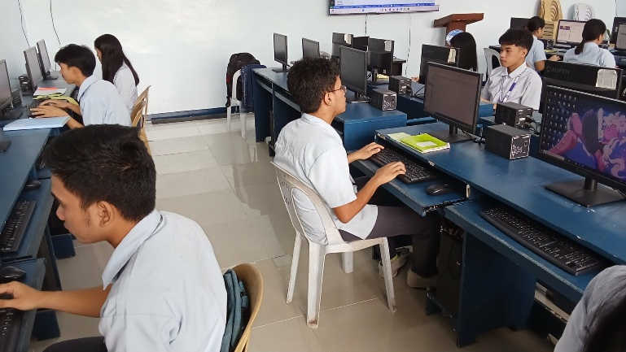

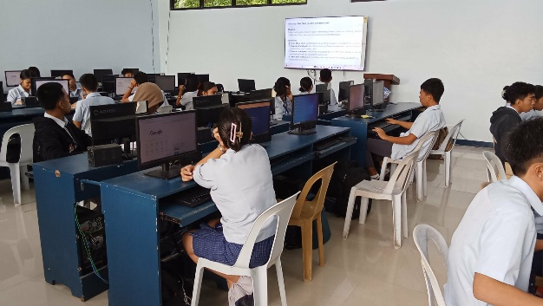

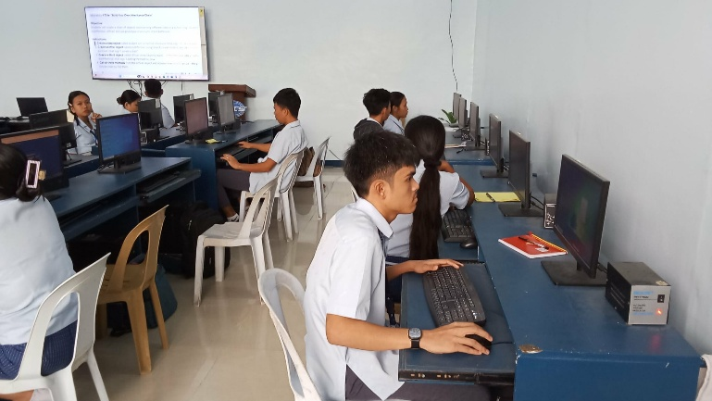
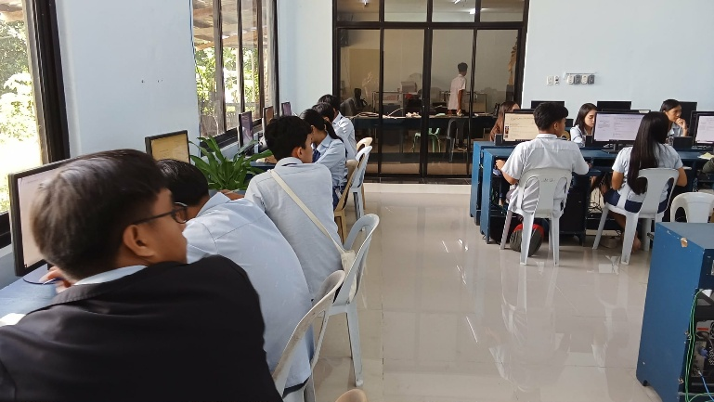

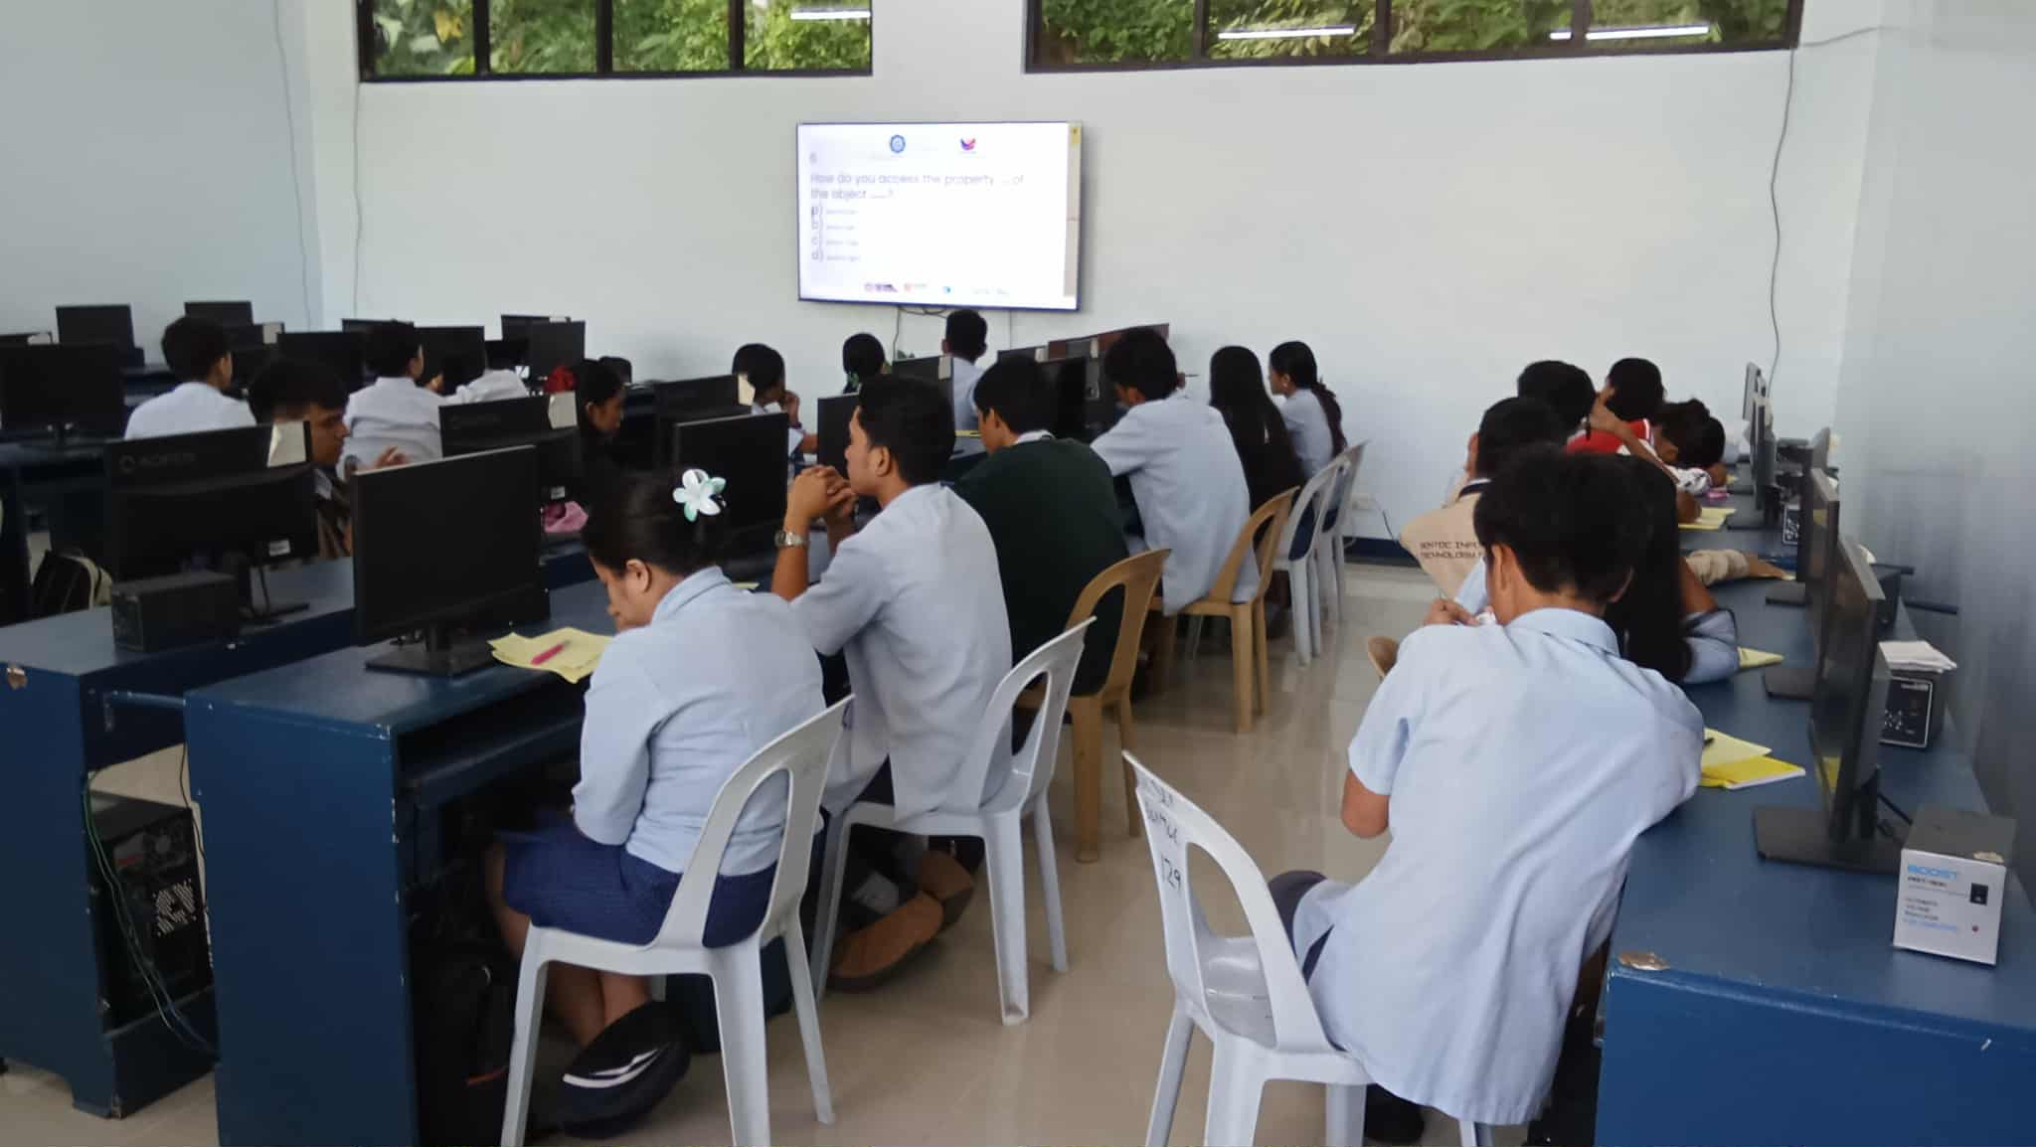
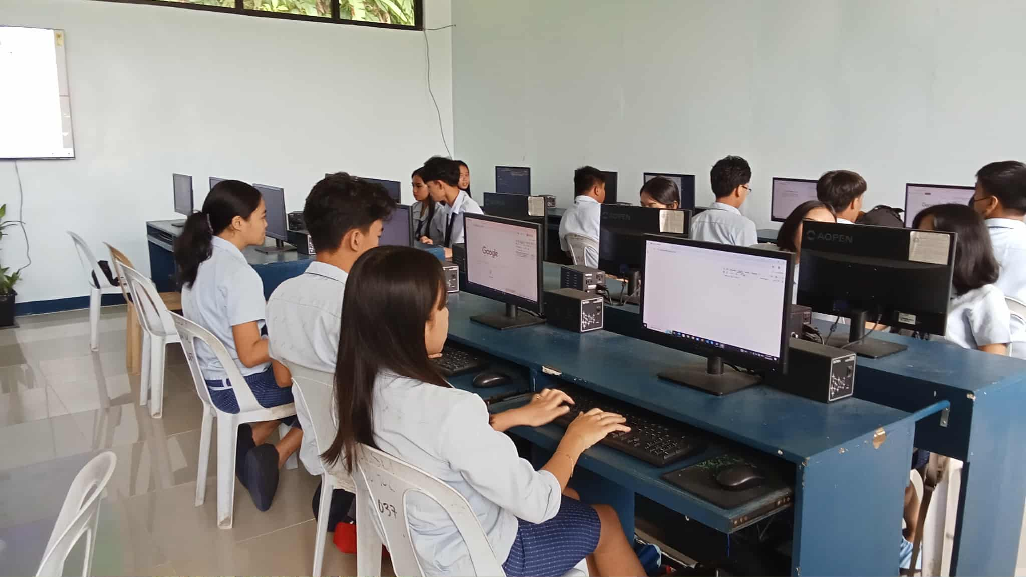

Prepared by: Approved:

JUNNIE RYH M. SUMACOT SHERWIN G. CADAY, PhD.
Instructor Program Chair

